**8×8 LED Matrix MAX7219 with Arduino**

Introduction

An LED matrix is a two dimensional array of LEDs that can be used to display symbols, characters or even images. Based on the orientation of the LEDs in the matrix, there can be two types of LED matrices.They are Common Row Anode and Common Row Cathode.

MAX 7219 is a common cathode display driver with serial input and parallel output. It is used to interface microprocessors and microcontrollers with 64 individual LEDs. The 8 x 8 LED matrix is connected to the MAX 7219. The data input is received from the Arduino board to the MAX7219.

One pin provides the clock signal to the LED display driver IC (MAX 7219) while another pin is used to transmit the serial data to the IC for displaying on the LED matrix.

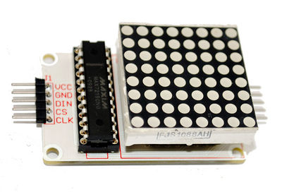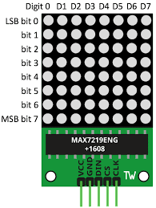

Components

Arduino uno

8*8 LED matrix display module(MAX7219)

Breadboard

Connecting wires

Application

* Arduino based 8 x 8 LED matrix display uses only 3 pins of the Microcontroller. Hence, it can be used in applications where displaying information is a part of the system in which other pins of the microcontroller can be used for other peripherals.
* LED Matrix is a basic form of display device that is used for displaying information at public places like bus or train stations.
* Multiple LED matrices can be combined to form large displays and can be used to display images with multi colors.

Objective

**During This activity ,you will help students to achieve following objectives**

**1.** Understanding the principle and operation MAX7219 LED matrix module

2. Design algorithm and flowchart for how digital data displayed in led matrix

3. Programming MAX7219 LED matrix module using Arduino uno

4. Interfacing MAX7219 LED matrix module with Arduino uno

Programming steps

1. Install LED matrix library

https://github.com/shaai/Arduino_LED_matrix_sketch/archive/master.zip

1. Initialize number matrix and input output pin
2. Define variable i, increment number matrix by 1
3. Read data sent at matrix display
4. Display data ‘HELLO’

Program

#include "LedControlMS.h"

//pin 12 is connected to the DataIn

// pin 11 is connected to the CLK

//pin 10 is connected to LOAD

#define NBR_MTX 1 //number of matrices attached is one

LedControl lc=LedControl(12,11, 10, NBR_MTX);//

void setup()

{

  for (int i=0; i< NBR_MTX; i++)

  {

    lc.shutdown(i,false);

  /* Set the brightness to a medium values */

    lc.setIntensity(i,8);

  /* and clear the display */

    lc.clearDisplay(i);

                delay(500);

  }

}

void loop()

{

     lc.writeString(0,"HELLO");//sending characters to display

     lc.clearAll();//clearing the display

     delay(1000);

}

Hardware instructions

Connect LED MATRIX module to Arduino uno by following connection

D10 ------------------LOAD or CHIP SELECT of LED module

D11 ------------------CLOCK of LED module

D12 ------------------DATA IN of LED module

+5V ------------------VCC of LED module

GND ------------------GND of LED module

